Project Design Phase-II

Data Flow Diagram & User Stories

|  |  |
| --- | --- |
| Date | 15 October 2022 |
| Team ID | PNT2022TMID38164 |
| Project Name | Project – Smart farmer-IoT enabled smart farming application. |
| Maximum Marks | 4 Marks |

# Data Flow Diagrams:

A Data Flow Diagram (DFD) is a traditional visual representation of the information flows within a system. A neat and clear DFD can depict the right amount of the system requirement graphically. It shows how data enters and leaves the system, what changes the information, and where data is stored.

Example: DFD Level 0

# Example: [(Simplified)](https://developer.ibm.com/patterns/visualize-unstructured-text/)

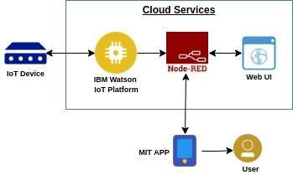

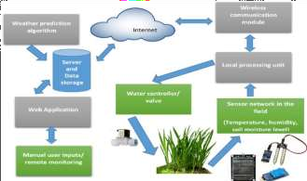

**User Stories**

Use the below template to list all the user stories for the product.

|  |  |  |  |  |  |  |
| --- | --- | --- | --- | --- | --- | --- |
| **User Type** | **Functional Requirement**  **(Epic)** | **User Story Number** | **User Story / Task** | **Acceptance criteria** | **Priority** | **Release** |
| Customer | IoT devices | USN-1 | Sensors and wi-fi module |  | High | Sprint-1 |
| Customer | Software | USN-2 | IBM Watson IoT platform, Workflows for IoT scenarios using Node-red |  | High | Sprint-2 |
| Customer | MIT app | USN-3 | To develop an application using MIT |  | High | Sprint-3 |
| Customer | Web UI | USN-4 | To make the user to interact with the software. | User can access the app for the services. | High | Sprint-4 |
|  |  |  |  |  |  |  |

|  |  |  |  |  |  |  |
| --- | --- | --- | --- | --- | --- | --- |
|  |  |  |  |  |  |  |
|  |  |  |  |  |  |  |
|  |  |  |  |  |  |  |
|  |  |  |  |  |  |  |
|  |  |  |  |  |  |  |
|  |  |  |  |  |  |  |
|  |  |  |  |  |  |  |